BSC – HGP - Assignment 01

Currency Converter

UI Design Document

**Student Name:** Sarah Brennan

**Student Number:** 2962279

# UI Design Choice

## Location

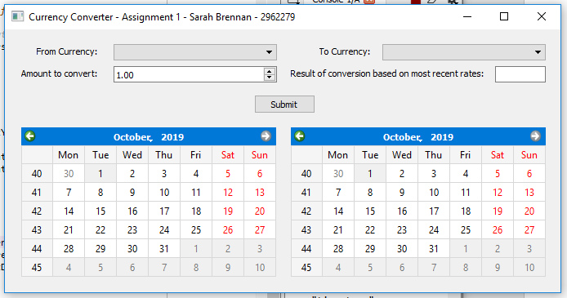

Screenshot to show layout of the application

I put the application location 300 down and 400 across as I wanted to be able to select the GUI easily if Spyder was using half of the PC screen.

In the application I put the combo boxes for currency at the top as this needs to be filled in by the user before any converting can take place.

I then put a spinner box and text box under this as need to get the amount the user wants to convert and then once the user selects submit button, which is in the middle beneath these again, the text box populates with the conversion.

I then placed the calendars below this and if a date is selected in the left calendar, then that historic conversion is printed for user.

## Size

I made sure that the widgets on the left side were similar sizes e.g. from currency combo box is the same size as the spinner box and that they end at the same point as the left calendar. I also made sure that the labels end at the same point so it looks good:

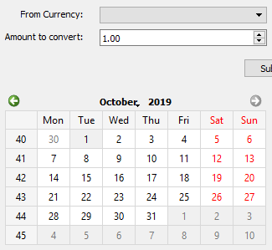

On the right, I made sure that the bottom label and right calendar start at same point and that the size of each widget are so that they end at the same point on the right as the calendar:

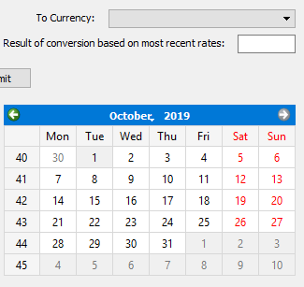

I kept the submit button at the default size:



## Widgets used

I used combo boxes for the currency selector as it will be easier to add more currencies to the list if need be.

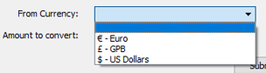

I made the amount to convert a spinner box as can only take number as input, which worked for me as didn’t have to create error checking on a text box:



I made the results print to a text box that was read only so it could print to that, but the data inside could not be edited by user:

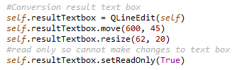

# Items that are working and not working

In the application, the user can select from 3 different currencies to convert from and to:



If the user does not select a currency in 1 or both of the como boxes an error message appears for user:

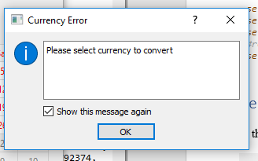

If the user selects a previous date to get the conversion from, the application will do this:

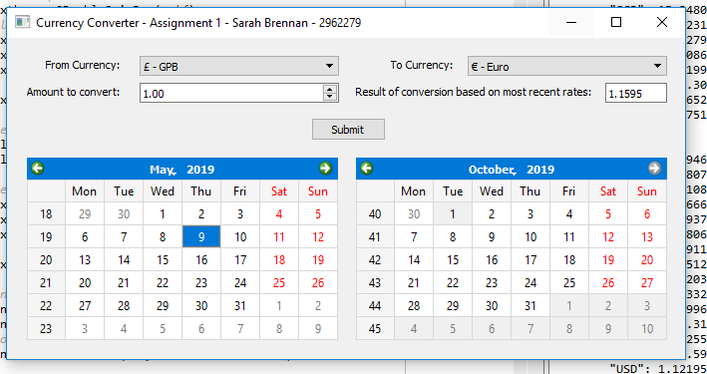

However, if the user selects something from the right calendar, nothing happens as only read from left calendar the date to choose.

If the user doesn’t select a previous date from the calendar, the conversion will be based on the current date:

